Nama : Siti Fauziyah

NIM : 18090019

Kelas : 5B

**Laporan Pratikum 4**

1. Source Code

Web.php → controllers

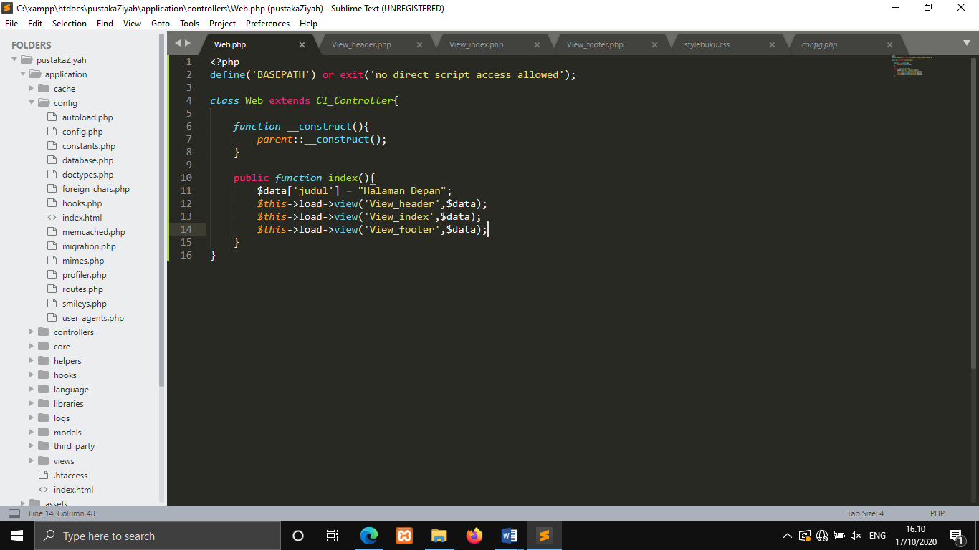

Setelah mengalami perubahan

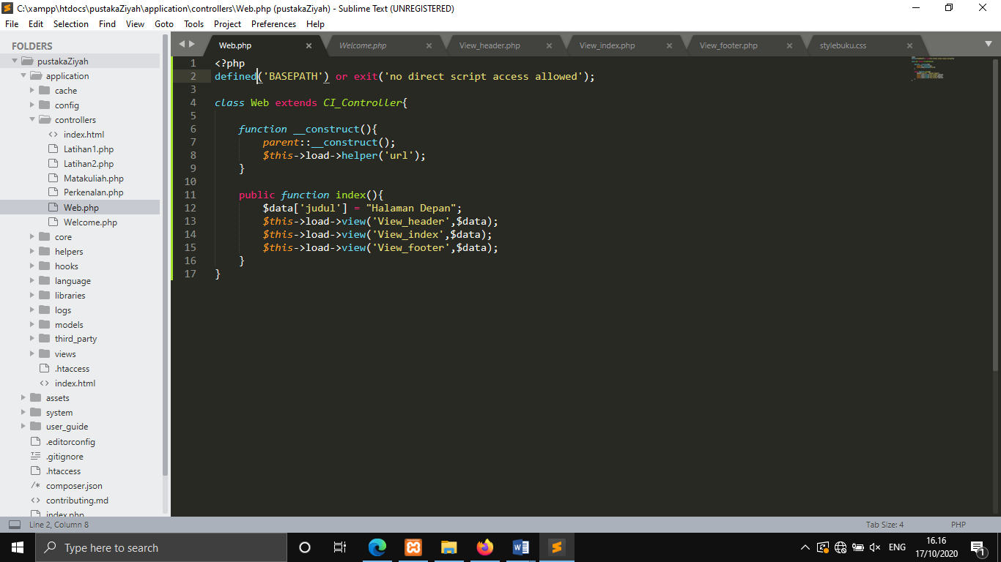

View_header.php → views

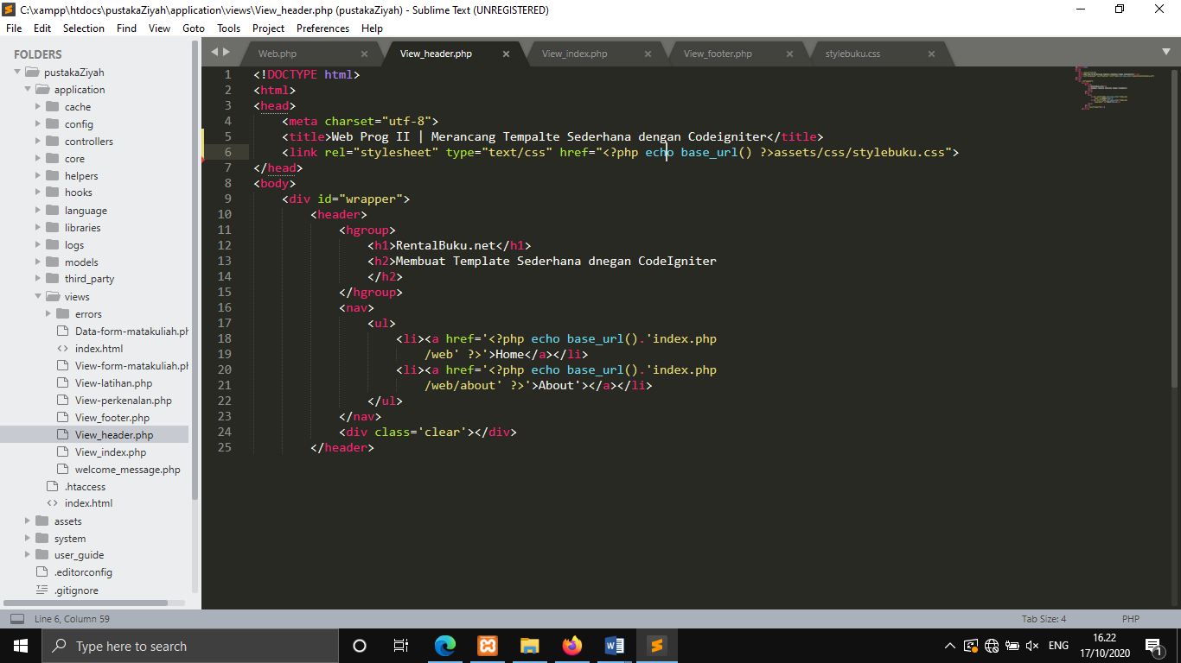

View_index.php → views

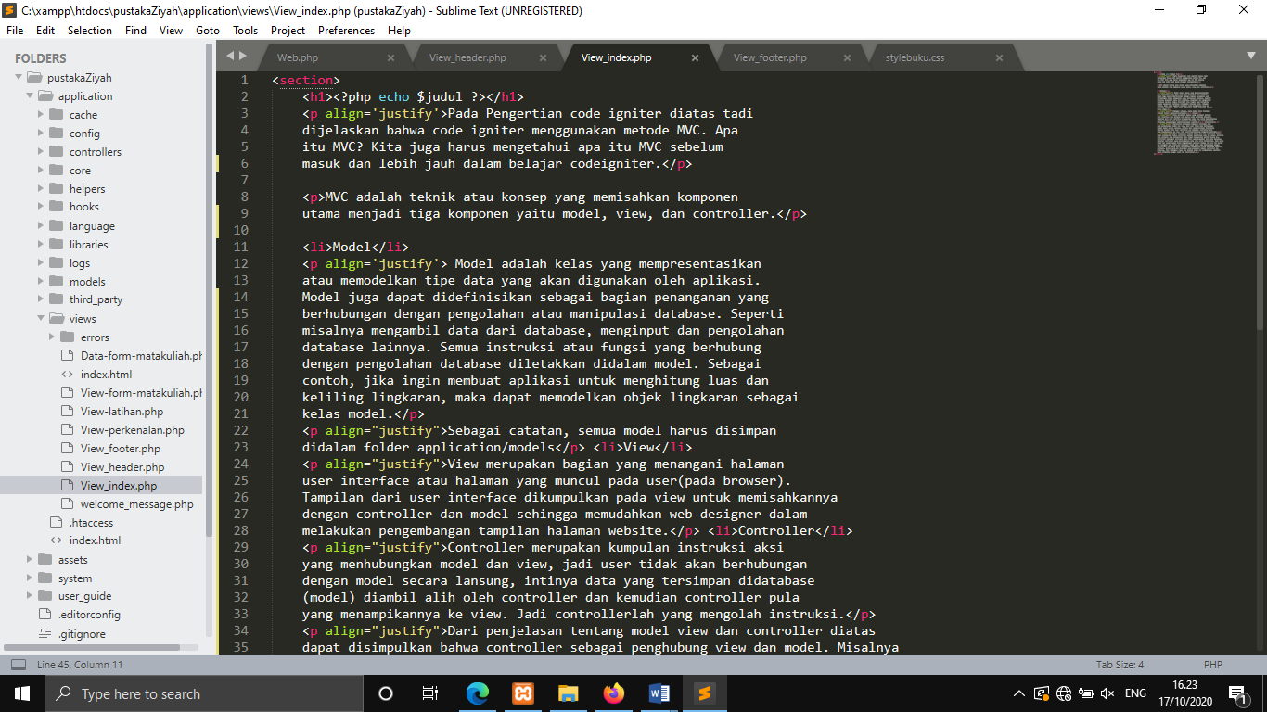

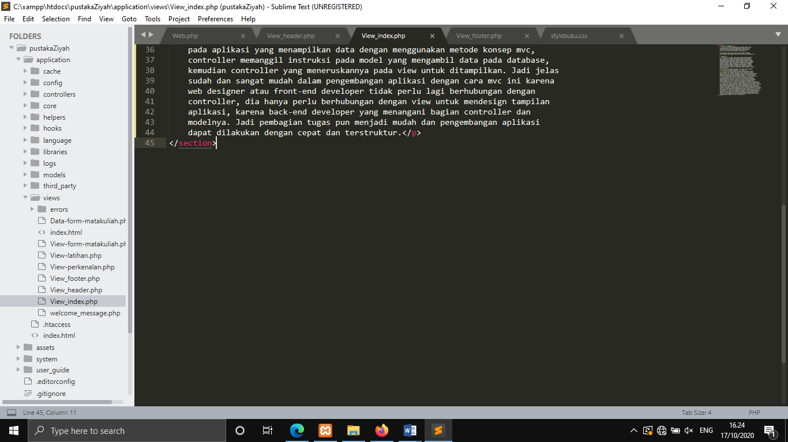

View_footer.php → views

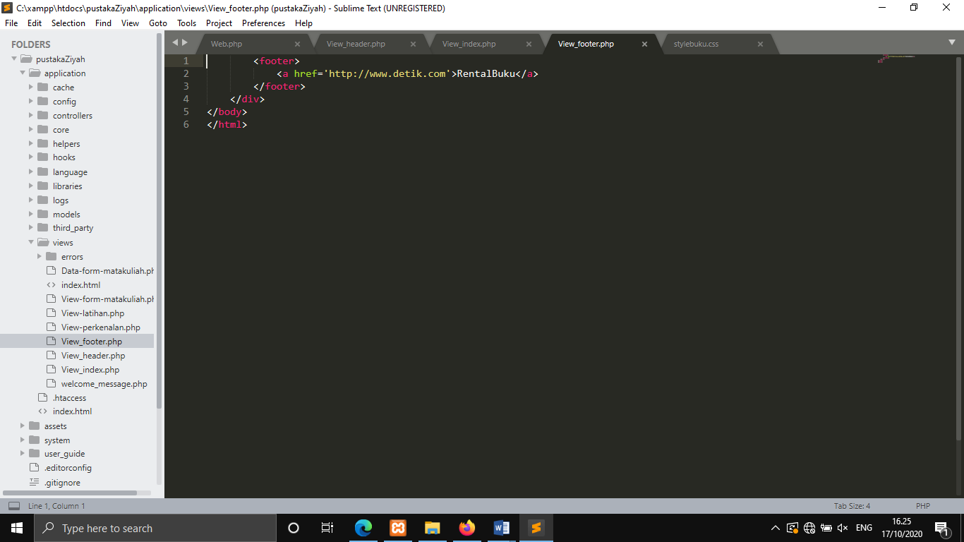

stylebuku.css → css

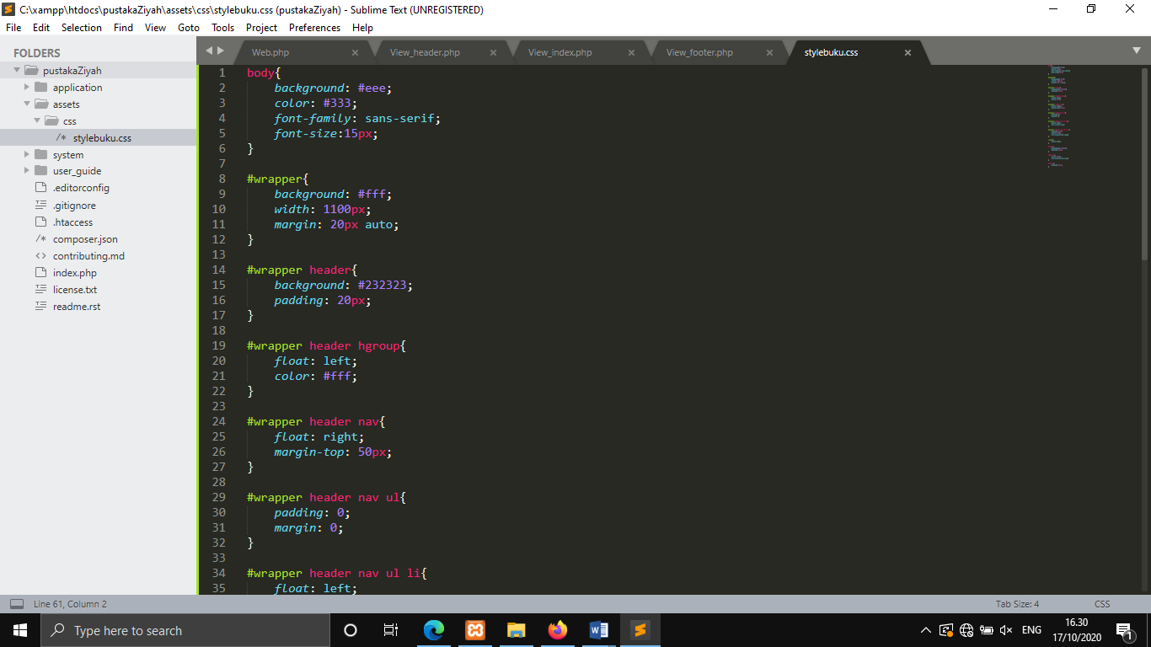

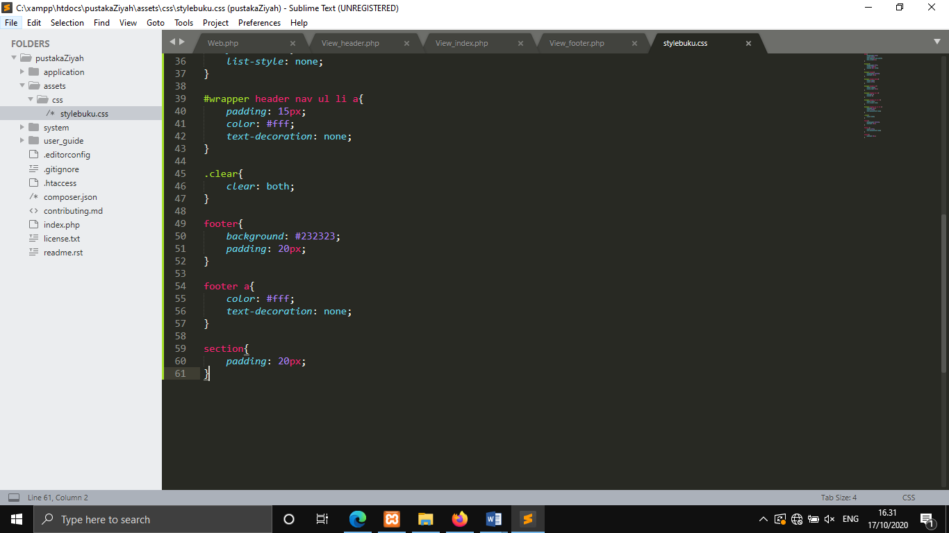

1. URL

<http://localhost/pustakaZiyah/Web>

1. Capture Output Program

